**Studying and Developing an Artificial Intelligence System for Sentiment Analysis on Social Networks (FCI)**

**Project Plan**

**V0.1**

**Prepared by:**

| Student Number | Student Name |
| --- | --- |
|  |  |
| 103792054 | Phung Xuan Tung |
| 103432499 | Nguyen Duc Minh |
| 103572382 | Nguyen Le Thang |
| 103426670 | Ngo Anh Tu |
|  |  |
|  |  |
|  |  |
|  |  |

Contact:

Date:

**REVISION HISTORY**

| **Version** | **Date Released** | **Comments/Changes** |
| --- | --- | --- |
| 0.1 | 28th January, 2024 | First Draft |
| 0.2 | 26th February 2024 |  |
|  |  |  |
|  |  |  |
|  |  |  |
|  |  |  |

**Table of Contents**

**1** **EXECUTIVE SUMMARY 4**

**2** **BACKGROUND 4**

**3** **OBJECTIVES 4**

**4** **SCOPE 4**

**5** **OUT OF SCOPE 5**

**6** **CONSTRAINTS AND DEPENDENCIES 5**

**7** **ASSUMPTIONS 6**

**8** **RISKS 6**

**9** **DELIVERABLES 6**

**10** **ISSUES 7**

**11** **PROJECT TEAM STRUCTURE 7**

11.1 Roles and Responsibilities 7

**12** **PROJECT SIGNOFF 10**

**13** **APPENDIX A – GANTT CHART 11**

# Executive Summary

The purpose of this project is to analyze the Social Media Sentiments Analysis Dataset and gain insights into the emotions, trends, and behaviors of social media users across different platforms, hashtags, and countries. The project will use various analytical methods and tools to perform sentiment analysis, temporal analysis, user engagement analysis, platform-specific analysis, hashtag trends analysis, geographical analysis, and cross-analysis on the dataset. The project will deliver a cleaned and processed dataset file, a code notebook or script, a report or presentation, and a dashboard or interactive tool.

With the updated team schedule, we are currently working on a sentimental analysis for comments on sales websites.

# Background

Social media is a powerful and influential medium for communication, information, and entertainment. It allows users to create and share content, express their opinions and emotions, interact with others, and follow the latest news and events. Social media content reflects the diverse and dynamic nature of human sentiments, as well as the social and cultural contexts of the users. Analyzing social media content can provide valuable insights into the emotional landscape, the patterns and fluctuations of sentiments, the user behavior and preferences, and the variations and similarities across different platforms, topics, and regions. Such insights can help understand the social media phenomena, identify the opportunities and challenges, and improve the user experience and satisfaction.

# Objectives

The main objective of this project is to analyze the Social Media Sentiments Analysis Dataset and extract meaningful insights from user-generated content across various social media platforms. The project aims to explore the emotional landscape, identify trends and patterns, understand user behavior and preferences, and compare variations in content based on platform, hashtag, and country.

# Scope

The project scope includes the following tasks:

* Loading and cleaning the dataset
* Conducting sentiment analysis on the comment csv file
* Send the analyzed data into a json file
* Up the json file onto the website with Database
* Examining specific variations using the reorganizing column function
* Performing specific cross-analysis using the data Entering function
* Visualizing and summarizing the results with various charts

# Out of Scope

The project does not include the following tasks:

* Collecting or scraping new data from social media platforms
* Creating or modifying the sentiment categories or labels
* Predicting or modeling future trends or sentiments
* Evaluating the impact or influence of specific users or posts
* Recommending or suggesting actions or interventions based on the analysis.

# Constraints and Dependencies

The project is constrained by the following factors:

* The availability and quality of the dataset
* The accuracy and validity of the sentiment analysis method
* The limitations and assumptions of the analytical tools and techniques
* The time and resources allocated for the project.

The project depends on the following factors:

* The accessibility and compatibility of the dataset file
* The availability and reliability of the analytical software and packages
* The clarity and feasibility of the project objectives and scope

# Assumptions

The project is based on the following assumptions:

* The dataset is representative and comprehensive of social media content.
* The sentiment labels are consistent and appropriate for the text content.
* The timestamp column reflects the local time of the post origin.
* The user, platform, hashtag, and country columns are accurate and complete.
* The likes and retweets columns measure the user engagement and popularity of the content.

# Risks

The project faces the following risks:

* The dataset may contain errors, missing values, duplicates, or outliers.
* The sentiment analysis method may produce inaccurate or biased results.
* The analytical tools and techniques may have limitations or drawbacks.
* The project may encounter technical or logistical issues or delays.
* The project may not meet the expectations or requirements of the stakeholders.

# Deliverables

The project will produce the following deliverables:

* A cleaned and processed dataset file
* A code notebook or script with the analysis steps and outputs
* A report or presentation with the key findings and insights
* A dashboard or interactive tool with the visualizations and summaries

# Issues

The sentiment analysis method may require fine-tuning or customization.

The analytical tools and techniques may require installation or configuration.

The project may face ethical or legal challenges or constraints.

The project may require revisions or modifications based on the feedback or changes in the scope.

# Project team Structure

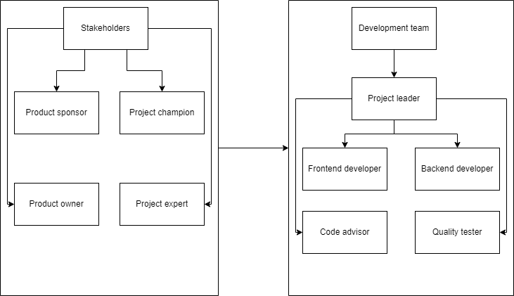

* 1. Roles and Responsibilities

| **Role** | Person responsible | Description |
| --- | --- | --- |
| **Product Sponsor** | Mr. Cuong | Typically, the product sponsor is a high-level executive who provides financial support and an overall vision for the project through their involvement. It is their responsibility to ensure that the project is in line with the strategic objectives of the organization, to secure funding for the project, and to make sure that the project has all the resources that it needs. |
| **Product Owner** | Mr. Xuan Hai | The product owner represents the end-users and stakeholders' interests. They are responsible for defining the project's goals, prioritizing the backlog of work, and ensuring that the development team understands the requirements. The product owner is the key decision-maker regarding what features the product will have. |
| **Project champion** | Mr. Ngoc Le | The project champion is an advocate for the project within the organization. They help in removing organizational barriers, facilitate necessary approvals, and work to maintain enthusiasm and support for the project across different departments. |
| **Project expert** | Ms. Linh | The project expert brings in-depth knowledge related to the project's subject matter. They provide technical or business expertise, guide the team on specific challenges, and ensure that the solution developed aligns with best practices and industry standards. |
| **Project leader** | Phung Xuan Tung | The project leader is responsible for leading the project team and managing the day-to-day operations of the project. They plan, execute, and monitor the project, ensuring that team members are working effectively towards the project goals. |
| **Data cleaner** | Nguyen Duc Minh | The data cleaner is responsible for ensuring the accuracy, completeness, and consistency of data within the project's databases or data sets. This role is critical in maintaining the integrity of data, which serves as the foundation for analysis, reporting, and decision-making processes within the project. |
| **Data analyst** | Le Xuan Thang | The data analyst is in charge of evaluating data, applying statistical methods to analyze findings, and giving the project team regular reports, insights, and analytical support. The success of the project is directly impacted by this role's ability to transform data into information, information into insight, and insight into business choices. |
| **Project advisor** | Ms. Linh | The project advisor, often an experienced developer or engineer, provides guidance on coding standards, reviews code for quality and efficiency, and helps in solving complex technical issues that the development team faces. |
| **Quality tester** | Ngo Anh Tu | The quality tester is responsible for ensuring that the software product meets quality standards. They conduct various tests, identify bugs, and collaborate with developers to ensure that the final product is free of defects. |

# Project Signoff

The signatures of the people below document approval of the formal Project Plan. The Project Manager is empowered by this charter to proceed with the project as outlined in this document.

For and on behalf of ***INSERT CLIENT NAME***:

Signed:_______________________________________ Date:_____________

( )

For and on behalf of the Project Team:

Signed:_______________________________________ Date:_____________

( , Project Manager)

For and on behalf of Swinburne University of Technology:

Signed:_______________________________________ Date:_____________

(, Project Supervisor)

# Appendix A – Gantt Chart

Please see attached MS Project file.

